

Software Engineering Department
ORT Braude College
Capstone Project Phase B
GitHub
Link to video

Data Pulse
D-9 Decentralized P2P File Sharing Platform

Submitted by:
Ofek Ben Avraham
Rotem Porat

Supervised by:
Ronen Zilber

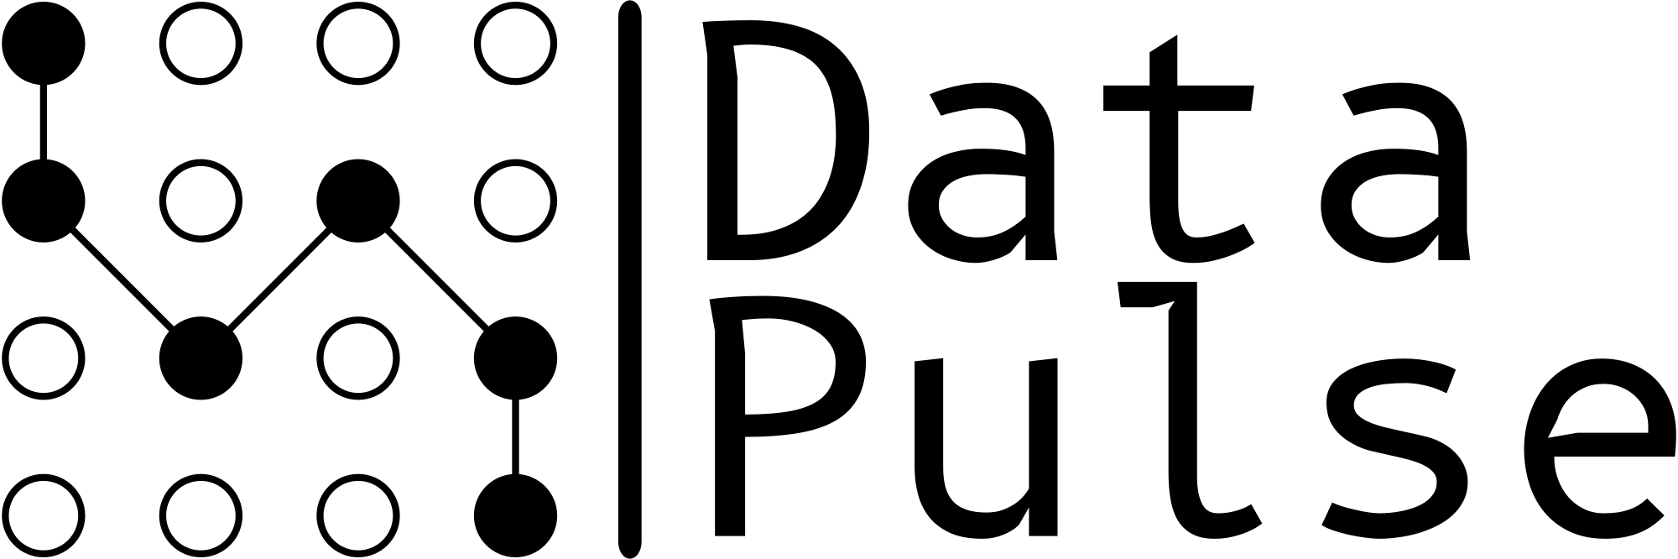

Abstract 4
Introduction 4
1. System Overview 4
1.1 System Objectives and Purpose 4
1.2 Key Features of the System 5
1.3 Communication and Data Transfer 5
1.4 User Interface 6
1.5 Target Audience 6
Solution Description 6
2. System Architecture 6
Deployment Diagram 8
Flowchart 9
Login/Registration Process 9
File Upload Process 10
File Download Process 11
Logout Process 12
Risk Management 13
Constraints and Challenges 13
3.1 Evaluation Criteria for Distributed File Sharing Platforms 13
3.2 Redundancy Strategies 14
Verification and Evaluation 15
4.1 Test Coverage Areas 15
4.1.1 System Infrastructure Tests 15
4.1.2 User Management Tests 15
4.1.3 File Operations 15
4.1.4 Security Implementation 15
4.2 Test Results Analysis 16
4.2.1 Performance Metrics 16
4.2.2 Key Findings 16
4.3 Testing Methodology 16
4.3.1 Environment Setup 16
4.3.2 Mock Implementation 17
4.3.3 Importance of Test Suite 17
Development Process 18
5.1 Research Phase 18
5.1.1 Architecture Design 18
5.2 Development Phase 18
5.3 Tools Used 19
5.4 Challenges and Solutions 20
5.5 Results and Conclusions 22
5.6 Lessons Learned and Future Improvements 23
User guide 25
Login/Registration 25
6.1 Login Process 25
Main Interface 26
6.3 Navigation System 26
6.4 File Management 26
6.4.1 Uploading Files 26
6.4.2 Downloading Files 27
6.5 File Organization 28
6.6 Real-Time Monitoring 29
Maintenance Guide 30
7.1 System Overview 30
7.1.1 Main Components 30
7.2 Features 30
7.3 How DataPulse Works 30
7.4 System Requirements 31
7.4.1 Software Requirements 31
7.5 Installation Process 31
7.6 Security Configuration 31
7.6.1 Encryption Settings 31
7.6.2 Authentication 32
7.7 Troubleshooting Guide 32
7.8 Monitoring and Recovery 32
7.9 Update Process 33
7.10 Future Improvements 33
7.10 System Architecture and Process Flows 34
References 37

Abstract
DataPulse is a decentralized file-sharing platform designed to overcome traditional bandwidth limitations through a peer-to-peer (P2P) architecture. The system incorporates secure user authentication and token-based authorization, ensuring controlled access to upload and download operations. Files are divided into chunks, compressed into ZIP files for storage, and dynamically encrypted with the requester’s public key during transfer, ensuring secure and efficient data exchange. A central tracker server facilitates peer discovery, maintains chunk availability records, and coordinates active connections. The platform supports parallel downloads from multiple peers, optimizing bandwidth usage and enabling efficient, reliable file retrieval. By addressing the bottlenecks of traditional server-based methods, DataPulse offers a robust solution for large file sharing, providing a practical platform that guarantees quick, reliable, and efficient file distribution.

Introduction

System Overview
Our system implements a peer-to-peer file-sharing platform enabling users to efficiently distribute and download various types of files, including videos, movies, images, and other content. The system employs a distributed architecture where users (peers) can both upload and download files, optimizing bandwidth usage through segmented file transfer protocols.

1.1 System Objectives and Purpose
The primary goal of the file-sharing system is to provide an efficient, secure, and user-friendly platform for sharing and accessing digital files over a decentralized network. The system overcomes the inherent limitations of traditional server-based file-sharing methods, such as bandwidth bottlenecks, server overload, and scalability issues.
To achieve these goals, the system integrates segmented file transfer, encryption protocols, and decentralized storage methods. By dividing files into smaller encrypted chunks, the system ensures faster transfer speeds and robust data security. Additionally, decentralized storage eliminates dependency on a single server, thereby enhancing scalability and resilience. These features together contribute to a highly efficient and secure file-sharing experience.
This platform enables users to upload, distribute, and download content with high performance and strong data encryption. The use of encryption and chunk-based storage ensures user data remains protected while optimizing bandwidth utilization and retrieval times. Communication protocols and peer-to-peer discovery further strengthen the decentralized framework, guaranteeing reliable file distribution.

1.2 Key Features of the System
- Decentralized File Distribution: The system eliminates dependency on a central server by distributing file chunks among participating peers. This reduces server loads, enhances data availability, and ensures that files remain accessible even in case of peer failures or network disruptions.
- File Chunk Encryption and Compression: Uploaded files are segmented into smaller chunks, which are individually encrypted using advanced algorithms. Each chunk is further compressed to optimize storage and transmission efficiency. This dual approach ensures that data remains secure during transfers while minimizing bandwidth usage and storage overhead.
- Torrent-based Transfer Protocols: A dedicated tracker server facilitates the discovery of peers, manages connections, and synchronizes data transfers across the network. This tracker ensures seamless file-sharing operations by maintaining updated records of peers and their available file chunks, optimizing retrieval processes.
- Simultaneous File Retrieval: To maximize efficiency, file downloads are executed in parallel by retrieving chunks from multiple peers simultaneously. This mechanism ensures optimal bandwidth utilization, significantly reducing download times, and enhancing the overall user experience.
- User Authentication: The platform incorporates secure login mechanisms to protect user accounts. Essential user details, including email, IP address, and port, are registered and maintained by the tracker server. This data facilitates efficient peer-to-peer communication and enhances the system's security by ensuring that only authenticated users can interact within the network.
- User-Friendly Interface: The system features a dynamic search bar and visual previews of files, ensuring accessibility for users with varying levels of technical expertise. This design provides a familiar and intuitive environment for discovering, uploading, and downloading content.

1.3 Communication and Data Transfer
Communication and data transfer in the system are seamlessly managed through the tracker, which plays a crucial role in facilitating peer discovery and coordinating the distribution of file chunks. To enhance efficiency, advanced algorithms are employed to handle simultaneous data requests, ensuring optimal bandwidth utilization. These algorithms also adapt to varying network conditions, maintaining stable and reliable communication throughout the file-sharing process. In the event of errors, such as a chunk failing to download, the system reconnects and sends a new request to another peer holding the required chunk, ensuring continuity and data integrity.

1.4 User Interface
The user interface was designed with a focus on simplicity and user-friendliness, inspired by the intuitive design of platforms. One of the key goals for improvement was to create an interface that is easy to navigate and accessible to all users. Through this interface, users can effortlessly browse, upload, and download files. Additionally, real-time updates are displayed during file transfers, providing information such as progress percentages and estimated completion times, ensuring users always stay informed about the status of their actions.

1.5 Target Audience
The platform is designed for diverse audiences, ranging from individual users to businesses. Its flexibility and functionality make it suitable for multiple use cases:
- Individual Users: Ideal for those seeking a secure and efficient platform to share personal files, videos, images, or documents. For example, a user might share vacation photos with friends and family privately and securely.
- Content Creators: Enables creators to distribute large multimedia files, such as video projects or high-resolution images, to their audience without relying on costly server-based hosting services.
- Businesses and Enterprises: Offers secure and scalable solutions for sharing large datasets, documents, or media within and across organizations. For instance, a company can use the system to distribute internal training videos or large design files to remote teams without risking data breaches or delays.
This system’s design and functionality ensure that users from various backgrounds can leverage it effectively for their specific needs.

Solution Description

System Architecture
The architecture of the system is designed to support a fully decentralized peer-to-peer file-sharing network with the following components:
- Peers: Each peer can perform multiple roles, including uploading files, downloading files, serving as a source for file chunks, and making requests for chunks from others. This dual role ensures that all users contribute to the system's operation.
- Tracker Server: A centralized tracker server manages the metadata for files and facilitates the discovery of peers. It tracks which peers have which file chunks and provides this information when a peer makes a request.
- Backend: Implemented in Python, the backend handles user authentication, and communication with the tracker server, and manages file segmentation, encryption, and chunk distribution.
- Database: MongoDB is used for storing user data, such as login credentials and peer information, to manage access and maintain security.
- Frontend: Built with Angular, the frontend provides an intuitive user interface where users can browse, search, upload, download files, and log in or out of the system. The interface also displays real-time progress updates on file transfers, showing percentages based on the number of chunks successfully transferred.

Deployment Diagram
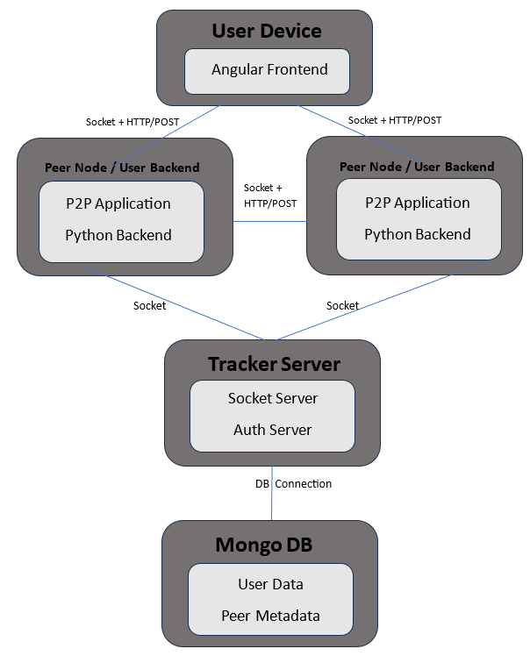
The deployment diagram illustrates a P2P file-sharing system architecture consisting of four main physical components: the User Device running an Angular frontend in a web browser, multiple Peer Nodes containing local storage and P2P clients for file management, a central Tracker Server with Socket and Authentication services, and a MongoDB database for storing user data and peer metadata. The communication flows between these components are clearly defined: peers communicate with each other using both Socket connections and HTTP/POST requests for file transfers, maintain Socket connections with the Tracker Server for real-time updates, while the browser frontend communicates via HTTP/POST requests, and the Tracker Server maintains a database connection with MongoDB for data persistence. Additionally, there is HTTP/POST + Socket communication between the Angular UI device and the Peer Node, where the Socket is used to show real-time progress of file downloads. This architecture combines distributed P2P file sharing capabilities with centralized user management and tracking, enabling efficient file distribution while maintaining system coordination through the central tracker.

Flowchart
The activity diagram illustrates a comprehensive P2P file-sharing system architecture and workflow that combines centralized user management with distributed file sharing capabilities. The system encompasses four primary processes: user authentication, file upload, file download, and logout operations.

Login/Registration Process
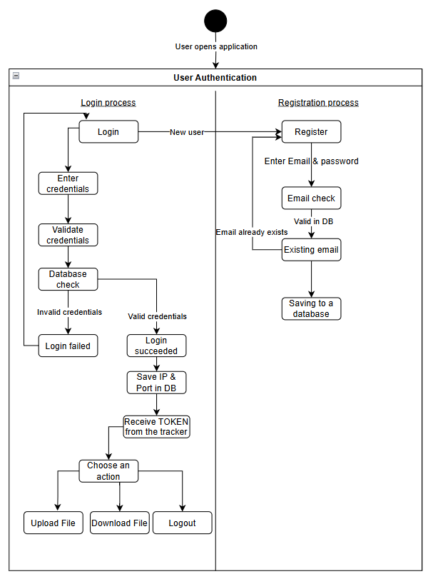
The system begins with a login interface where users enter their email and password. These credentials are verified against the database. Upon successful authentication, the user's IP address and port are stored in the DB, and the Tracker sends a Token to the peer for system operation authorization. This Token enables the user to upload files, download files, or log out. If authentication fails due to a non-existent user, the system redirects to the registration process. During registration, users must provide a valid email (checked against the DB for uniqueness) and other registration details, which are then stored in the DB for future authentication.

File Upload Process
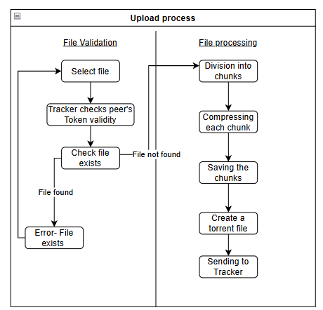
When a user initiates a file upload, the Tracker first validates the peer’s Token. After validation, it checks if the file already exists in the system. For new files, the upload process begins with the file being divided into chunks, which are stored in the peer’s chunks directory. Each chunk undergoes compression, and finally, a torrent file is created and sent to the Tracker. This torrent file contains metadata about the chunked file and is essential for future download operations.

File Download Process
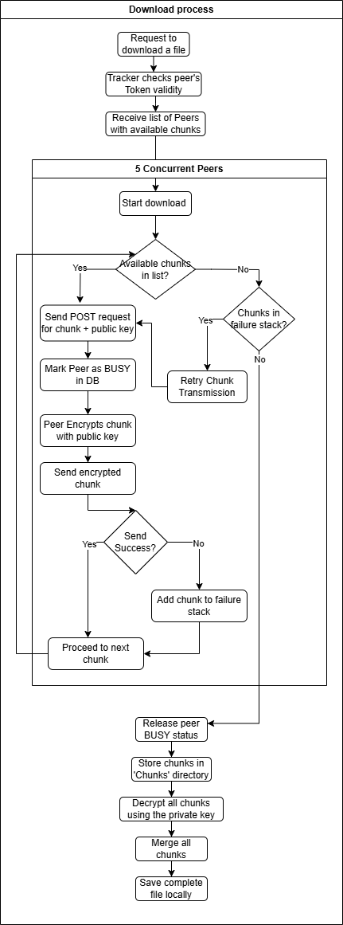
The download process begins with token validation by the Tracker. Once validated, the Tracker sends the requesting peer a list of available peers who have the required chunks. The system then initiates 5 concurrent threads, each simulating a peer connection. While chunks remain to be downloaded, each thread sends POST requests containing the desired chunk ID and a public key for encryption. The responding peer encrypts their chunk using this public key and transmits the encrypted chunk. Failed transmissions result in the chunk ID being added to a failure stack. After processing all initial chunks, the system attempts to download any failed chunks from the stack until all transfers are successful. Once complete, peers are marked as not BUSY (making them available for future transfers), chunks are decrypted using the private key, merged, and stored in the downloading peer’s chunks directory for future sharing. The final merged file is saved in the ‘Files’ directory for user access.

Logout Process
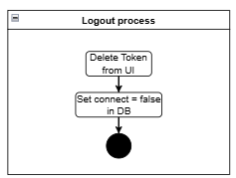
The logout procedure involves two main operations: first, the token is removed from the (User Interface), eliminating the user's ability to perform authenticated actions. Second, the user's status in the database is updated by setting their 'connect' parameter to false, indicating they are no longer active in the system. This simple but crucial process ensures proper session termination and system security.

Risk Management
Throughout the development of the DataPulse system, effective risk management was crucial to ensure the successful delivery of the project within its time and resource constraints. The primary objective of risk management was to anticipate potential challenges, plan mitigation strategies, and prepare for unexpected situations.
Technical Risks: To address potential technical challenges, thorough research was conducted during the planning phase. Prototyping key system components and testing with mock data allowed the team to uncover issues early and devise solutions.
Time Constraints: Task prioritization played a critical role in managing time efficiently. Focus was placed on core features such as file chunking, encryption, and peer discovery, with additional features like the user interface and advanced encryption deferred to later stages.
Security Risks: A layered approach to security was implemented. Encryption algorithms were selected based on their balance between security and performance, and peer-to-peer communication was fortified through secure channels. Regular security audits were conducted to identify and fix vulnerabilities. Contingency Plans: In addition to risk mitigation strategies, contingency plans were established to address unforeseen circumstances. For example, a fallback mechanism was integrated into the peer discovery process to handle instances where certain peers were unavailable or unresponsive.
The risk management approach allowed for quick adaptations during the development cycle, ensuring the delivery of a robust and functional system on time.

Constraints and Challenges

3.1 Evaluation Criteria for Distributed File Sharing Platforms
In the development of DataPulse, continuous evaluation against critical criteria for distributed file-sharing platforms ensures that the system meets high standards of functionality and performance. These criteria include:
Security: Security is a top priority for DataPulse. The system incorporates advanced encryption protocols for both data transmission and storage, ensuring that all interactions remain secure. Access control mechanisms are embedded into the system to prevent unauthorized access to sensitive data, ensuring integrity and compliance with security standards.
Scalability and Efficiency: The architecture of DataPulse was designed to handle an ever-growing user base without compromising on performance. The system employs a modular architecture, enabling horizontal scaling to distribute workloads efficiently. Load balancing algorithms are used to manage network traffic evenly, preventing bottlenecks. The peer-to-peer topology allows for the parallel transfer of file segments, enhancing efficiency.
These criteria are central to ensuring that DataPulse remains robust, secure, and scalable as it evolves.

3.2 Redundancy Strategies
In a distributed file-sharing system, redundancy is essential to maintain data availability and ensure reliability. In DataPulse, redundancy is achieved through multiple techniques:
Segmented File Transfer: Each file is divided into smaller pieces, which are distributed across multiple peers in the network. This segmentation improves the resilience of file transfers by ensuring that if one peer becomes unavailable, the file can still be reconstructed from other available pieces.
Parallel Transfers: By enabling simultaneous downloads from multiple peers, DataPulse enhances the speed of file transfer while ensuring that multiple copies of file segments exist across different peers. This strategy minimizes the risk of a single point of failure and maximizes the efficiency of the network.
File Integrity Verification: Each file segment undergoes hash verification to ensure that the data remains intact during transfer. A hash is computed for every segment before and after transfer, and the system compares the two to ensure data integrity. If a discrepancy is found, the corrupted segment is flagged for re-transfer, enhancing the reliability and consistency of file sharing across the network.
In addition to these strategies, DataPulse also includes recovery mechanisms to address failed transfers or node failures. If a node goes offline during a file transfer, the system automatically retries the transfer from another peer that holds the missing segments. This redundancy ensures that users can complete file transfers even in the event of network disruptions.

Verification and Evaluation
System testing is essential for ensuring the reliability and correctness of the DataPulse distributed file-sharing system. This chapter outlines the comprehensive testing strategy implemented to validate core functionalities, including file handling, encryption, peer authentication, and network operations. The primary objectives were to verify functional correctness, maintain data integrity, ensure encryption security, confirm proper network communication, and validate torrent file creation and management. The test suite, developed using Python’s unittest framework, encompasses distinct test cases covering all critical aspects of the system. All tests passed successfully, demonstrating the robustness and efficiency of the implementation.

4.1 Test Coverage Areas

4.1.1 System Infrastructure Tests
- IP Address Handling: Verifies the system can correctly obtain and validate IP addresses.
- Port Management: Ensures the system can find and allocate available network ports.
These tests confirm the system's ability to establish basic network connectivity

4.1.2 User Management Tests
- User Registration: Validates the user registration process.
- Peer Login: Tests the authentication system and token generation.
Both tests utilize mocking to simulate server interactions, demonstrating proper separation of concerns.

4.1.3 File Operations
- File Splitting and Merging: Tests the core functionality of splitting files into chunks and reassembling them.
- Large File Handling: Specifically tests the system's ability to handle files.
- File Type Detection: Ensures correct identification of various file formats.
- Torrent Creation: Validates the system's ability to generate torrent files with proper metadata.
- Final File Verification: Ensures data integrity through hash verification

4.1.4 Security Implementation
- Encryption/Decryption: Validates the cryptographic functions using RSA key pairs.
- Secure Downloads: Tests secure chunk downloading with encrypted communication.

4.2 Test Results Analysis

4.2.1 Performance Metrics
The test suite achieved a total execution time of 1.610 seconds for 11 tests, demonstrating efficient performance with a 100% pass rate and no failures or errors. Additionally, the system effectively handled large files of up to 10MB, ensuring proper chunking and seamless file operations.

4.2.2 Key Findings
- Robust Error Handling:The system demonstrates robust error handling by effectively managing various failure scenarios, including missing or corrupted chunks, network connectivity issues, invalid file types, and authentication failures. These capabilities ensure system reliability and resilience in diverse operational conditions.
- Scalability: The tests demonstrate the system's capability to handle files of varying sizes, process multiple chunks simultaneously, and manage concurrent network connections, ensuring efficient and scalable performance under different conditions.
- Security Implementation: The tests verify the proper encryption and decryption of data, ensuring secure peer-to-peer communication and safe user authentication, safeguarding both data integrity and system security.

4.3 Testing Methodology

4.3.1 Environment Setup
The testing framework uses temporary directories for test files, ensuring that no permanent changes are made to the file system during test execution. It also implements thorough cleanup procedures after each test, ensuring that all resources are properly released and the system is reset to its initial state. Additionally, the framework maintains isolation between tests by ensuring that the tests do not interfere with each other, preventing any side effects from one test affecting the results of another. This structured approach guarantees accurate and reliable test outcomes.

4.3.2 Mock Implementation
Network calls are properly mocked during testing to simulate real-world interactions without making actual requests to external servers. This ensures that tests remain fast and reliable without depending on the availability or stability of external resources. Server responses are simulated to accurately reflect expected behavior, allowing for comprehensive testing of how the system handles different scenarios. Additionally, external dependencies are controlled, ensuring that the tests remain consistent and unaffected by external factors, such as changes in external APIs or services, which might otherwise introduce variability into the results.

4.3.3 Importance of Test Suite
- Quality Assurance:Quality assurance validates the core functionality of the system, ensuring that all essential features perform as expected. It also focuses on maintaining system reliability, confirming that the system can handle various conditions without failure or degradation in performance. Furthermore, quality assurance verifies the implementation of security measures, ensuring that data integrity, encryption, and user authentication are correctly applied to protect the system from vulnerabilities and unauthorized access.
- Development Support: Unit testing plays a pivotal role in supporting development by facilitating safe refactoring, providing implementation examples, and documenting expected behavior. By validating individual components, unit tests ensure that developers can confidently modify and improve code without introducing new issues. They also serve as practical examples of how specific functionalities should be implemented, guiding developers in writing consistent and effective code. Furthermore, unit tests act as a form of documentation, clearly outlining the expected behavior of code units and aiding in maintaining code quality over time.
- Maintenance Benefits: Maintenance benefits include early bug detection, allowing issues to be identified and resolved before they escalate into major problems. Unit testing also helps prevent regression by ensuring that new changes or updates do not break existing functionality. Furthermore, it verifies system stability by regularly checking that the system continues to perform as expected over time, even as modifications are made. This proactive approach ensures that the system remains reliable and functional throughout its lifecycle.

Development Process
The development process for our file-sharing system was divided into four main stages: research, architecture design, development, and testing. We worked in sprints to ensure iterative progress and adaptability.

5.1 Research Phase
- We began by analyzing existing file transfer technologies, identifying their strengths, limitations, and potential areas for improvement. This included studying various file-sharing protocols and algorithms, such as BitTorrent, as well as encryption methods for securing data transfers.
- A significant focus was placed on understanding communication protocols, peer-to-peer (P2P) architectures, and bandwidth optimization techniques.

5.1.1 Architecture Design
After completing the research, we designed the system architecture. This included defining the roles of the key components:
- Frontend (Angular): Handles user interactions, such as login, upload, search, and download.
- Backend (Python): Manages core functionalities like user authentication, file chunking, encryption, and communication with the tracker server.
- Database (MongoDB): Stores user data for authentication and system management.
- Tracker Server: Facilitates peer discovery and manages metadata for uploaded files.
- Peers: Both act as servers for file chunks and requesters for file downloads.
The architecture emphasized modularity and scalability to support an increasing number of users and file sizes.

5.2 Development Phase
Backend: Implemented in Python, focusing on multiple core functionalities:
- User registration was handled using email and password, with the details securely stored in the MongoDB database.
- Peer-to-peer connections were managed to enable efficient file sharing, including sending requests for downloading chunks and managing connections between peers.
- Torrent files containing metadata about file chunks and peer information were sent to the tracker server.
- The backend supported user login, where a registered user could log in, and their IP and port information were stored temporarily for file-sharing purposes. These details were removed upon logout.
- Encryption and decryption processes ensured secure file sharing, while compression and decompression allowed efficient storage and transfer.
- Chunks were reassembled on the backend after download, with a tracking table to verify the completion and integrity of all chunks.
Frontend: Developed in Angular to provide an interactive user interface:
- Designed to ensure ease of use, the interface allows users to search for files, upload new files, and download existing ones.
- Real-time progress updates for file transfers are displayed, showing the percentage of chunks downloaded or uploaded.
- A seamless search feature enables users to find files efficiently, while the upload process is simplified for accessibility.
Database: Configured using MongoDB to securely manage and store user data:
- User registration details, including email and password, are stored securely.
- Upon user login, the IP and port of the user are temporarily stored for facilitating file sharing.
- The tracker also sends a token upon login for performing actions like uploading and downloading files. This token is securely stored in the database.
- This data is cleared upon user logout to maintain security and data integrity.

5.3 Tools Used
- Backend: Python
- Frontend: Angular
- Database: MongoDB
- Version Control: GitHub
- Development Methodology: Sprints

5.4 Challenges and Solutions
Managing Peer Connections
One of the significant challenges during the development process was ensuring stable and efficient connections between peers in a decentralized network. Managing such connections required addressing issues like peer availability, dynamic connectivity, and ensuring uninterrupted file sharing. To solve this, we implemented a tracker server that acts as a centralized coordinator. The tracker server maintains metadata about file chunks and peer connections, enabling it to manage which chunks of a file are stored on which peers. When a peer requests a file, the tracker server provides a list of available peers that have the requested file chunks. This system allows peers to dynamically request chunks based on their availability and connectivity status. By leveraging the tracker server, we ensured that file transfers remain stable and efficient, even as peers join or leave the network, optimizing both reliability and performance.
Encryption and Decryption
To address significant security challenges in our peer-to-peer file sharing system, particularly the threat of man-in-the-middle (MITM) attacks, we implemented a sophisticated hybrid encryption approach combining both RSA and AES algorithms. This security implementation is crucial as MITM attacks could potentially allow malicious actors to intercept and modify communications between peers, compromising both data integrity and user privacy.
Our encryption architecture utilizes a dual-layer approach. Each peer maintains their own unique pair of RSA keys - a public key and a private key. When a peer wants to receive a file chunk, it sends its public key along with the chunk request in the POST request. This public key will be used by the sending peer to encrypt the chunk data, ensuring that only the requesting peer (who holds the corresponding private key) can decrypt and access the data.
The process flow works as follows: When Peer A requests a file chunk, it includes its public key in the POST request to Peer B. Peer B receives this request and reads the requested chunk from its local storage. Peer B then uses Peer A's public key to encrypt the chunk data. The encrypted chunk is then transmitted to Peer A. Upon receipt, Peer A uses its private key to decrypt the chunk data. This process ensures that even if the transmission is intercepted, only Peer A can decrypt and access the actual chunk data.
The implementation includes careful attention to technical details. The system transmits the encrypted data in manageable blocks for efficient handling. Comprehensive error handling and buffer management ensure reliable and secure data transfer, even under challenging network conditions.
This robust security implementation effectively protects against various attack vectors. Man-in-the-middle attacks are thwarted as intercepted data remains encrypted and unreadable without the appropriate private key. Data tampering during transmission is prevented through encryption, making it impossible for attackers to modify the chunk data without detection.
The system maintains both security and performance objectives while preserving the distributed nature of peer-to-peer file sharing operations. By using RSA encryption, we ensure that file chunks can only be decrypted by their intended recipients, providing strong protection against unauthorized access and data interception while maintaining the performance requirements necessary for effective peer-to-peer file sharing.
Error Handling During Downloads Managing error scenarios during downloads was a significant challenge in the development process. One of the main issues was handling situations where chunks failed to download. These failures could occur due to a variety of reasons, such as peer unavailability, unstable network conditions, or incomplete data on a peer's side. Without proper handling, such scenarios could disrupt the file-sharing process, leading to incomplete downloads or significant delays.
To address this challenge, we implemented a stack-based mechanism to manage failed downloads. Whenever a chunk fails to download, it is immediately added to a failure stack, which temporarily stores all problematic chunks. This stack acts as a buffer, ensuring that failed chunks are tracked and not lost during the download process. Once all threads—representing peers—finish processing the initial list of chunks, they revisit the failure stack and attempt to download the unresolved chunks. During this stage, the system dynamically identifies alternative peers holding the required data and sends new download requests to them.
This mechanism offers several significant advantages. First, it enhances resiliency by systematically isolating and retrying failed chunks, ensuring no data is left behind. Second, it leverages parallelism, as multiple threads can process the failure stack simultaneously, improving the chances of successful downloads. Third, it minimizes overall delays by prioritizing retries for failed chunks rather than restarting the entire process. Finally, the stack-based approach ensures organized retries, preventing indefinite delays or redundant requests for the same chunk.
The tracker server plays a crucial role in supporting this process. By maintaining an updated list of peers and their available chunks, the server enables the system to efficiently locate alternative sources for failed chunks. This ensures that retries are targeted and efficient, even in cases where network conditions are unstable or peers become temporarily unavailable.
By combining the stack-based failure mechanism with dynamic peer discovery, the system achieves a high level of reliability and robustness. Even in challenging scenarios, such as network instability or peer failures, the file-sharing process remains smooth and uninterrupted. This approach minimizes disruptions for the end user and ensures a more efficient and seamless download experience.
Bandwidth Optimization Maximizing bandwidth utilization for faster file transfers was a crucial challenge during the development process. In traditional file downloads, bandwidth is often underutilized because the transfer relies on a single source, which may not fully saturate the available network capacity. This inefficiency becomes even more pronounced when dealing with large files or networks with high bandwidth capabilities, where a single connection cannot leverage the full potential of the network.
To address this challenge, we implemented a solution that enabled concurrent downloads of file chunks from multiple peers simultaneously. By dividing each file into fixed-sized chunks, we ensured uniformity in chunk size, which simplified the management of parallel downloads. Additionally, we defined a consistent chunk size across all peers to ensure compatibility and prevent discrepancies. For the final chunk, if it did not match the defined size, padding was added to fill the gap, ensuring that all chunks could be processed uniformly.
The system dynamically managed these parallel downloads, keeping track of the status of each chunk and verifying their successful completion. Once all chunks were downloaded, they were reassembled to form the original file. This approach not only optimized bandwidth utilization but also significantly reduced overall download time, enhancing the efficiency and user experience of the file-sharing system.

5.5 Results and Conclusions
Performance: The system achieved fast and reliable file sharing by leveraging parallel chunk downloads from multiple peers. By dynamically managing these parallel downloads, the system ensures efficient utilization of bandwidth, significantly reducing latency and overall download times. Additionally, the inclusion of a stack-based retry mechanism for failed chunk transfers enhances reliability and ensures continuity. Failed chunks are temporarily stored in a failure stack and revisited systematically, allowing the system to recover from interruptions without restarting the entire process.
Scalability: The architecture was designed to scale seamlessly with increasing user numbers and larger file sizes. Its modular design supports the addition of more peers and files without degrading performance. The stack-based retry mechanism further supports scalability by isolating failed chunks for retries, ensuring that even under high load, no data is lost. Load balancing mechanisms ensure even distribution of requests across the network, maintaining consistent system responsiveness under varying loads.
User Experience: The interface provides real-time updates on file transfer progress, including detailed status percentages and estimated completion times. Its intuitive design allows users to effortlessly search for files, upload new content, and monitor download activities, ensuring a transparent and user-friendly experience.
Security: Security: The system incorporates multiple layers of security to ensure data integrity and privacy. All file chunks are encrypted using AES-RSA before being transmitted, preventing unauthorized access during transfers. The use of a private key for decryption ensures that only authorized recipients can reconstruct the original file. Additionally, the tracker server verifies the validity of peer tokens to prevent unauthorized participation in the network. These measures collectively enhance the system’s robustness against data breaches and unauthorized access, providing a secure and trustworthy file-sharing environment.

5.6 Lessons Learned and Future Improvements
Throughout the development process of the DataPulse project, various challenges and opportunities arose, shaping the system's evolution and progress. The project was structured to tackle key components step-by-step, with each sprint focusing on specific tasks. This organization enabled efficient task allocation, facilitating parallel development. For instance, one team member worked on the encryption and decryption mechanisms, while another concentrated on file chunking and reassembly. This approach ensured steady progress and allowed for continuous improvement.
Strengths
The modular structure of the system played a vital role in its success, allowing each component to be developed independently and minimizing interdependencies. This enabled parallel work across multiple domains, helped prevent bottlenecks, and significantly accelerated the development process. The platform’s use of parallel chunk downloads from multiple peers further optimized bandwidth utilization, reducing latency and download times, ensuring smoother and faster file transfers and meeting the performance goals initially set. In addition, task allocation was handled efficiently, with the team focusing on specific areas such as encryption, file sharding, and system optimization. This collaborative approach allowed for specialized expertise in each domain, contributing to the overall success of the platform.
Potential Improvements
While the system has performed effectively within the given timeframe, it is important to recognize that the project's development was subject to time constraints, which limited the scope for further optimization. With additional time, several key areas could have been further refined. For instance, more comprehensive testing across diverse network conditions would have facilitated the early identification of potential issues, enabling more thorough system enhancement. Data security is a critical aspect, and future iterations of the system could benefit from integrating more advanced encryption algorithms, thereby improving data privacy and integrity. Moreover, investigating decentralized peer discovery models could enhance the system’s fault tolerance and responsiveness, particularly in dynamic network environments. Lastly, transitioning to a fully decentralized tracking system would remove the reliance on single points of failure, significantly improving network resilience and overall reliability.
Decisions and Trade-Offs
Several key decisions were made throughout the project to balance simplicity with advanced features. A centralized tracker was implemented to streamline peer discovery and management, although this approach resulted in reduced fault tolerance compared to a fully distributed model. This trade-off was essential to meet the project’s deadlines and ensure the development of a functional and manageable system within the scope of the initial design. Additionally, encryption strength was prioritized over the complexity of algorithms. While there is potential to integrate stronger encryption in future iterations, the project's time constraints necessitated a focus on securing file transfers using existing technologies.
Reflections
The sprint-based development methodology proved effective in managing tasks and ensuring iterative progress. Each sprint allowed for the identification and rapid resolution of issues, maintaining the project’s momentum. This approach facilitated consistent progress, enabling the team to remain focused on key goals while adapting to evolving requirements. By applying the lessons learned from this experience, future projects can benefit from even more optimized task allocation and execution strategies, further enhancing efficiency and project outcomes.

User guide
This guide provides step-by-step instructions for using our file sharing system - ‘DataPulse’. It covers all main functionalities including login, file upload, download, and monitoring processes.

Login/Registration


6.1 Login Process
- Click the ‘Login’ button located in the top-right corner of the screen.
- Enter your registered email address
- Enter your password
- Click the "Login" button
- If credentials are incorrect, a message will be displayed on the side accordingly
- Successful login grants access to file upload and download actions
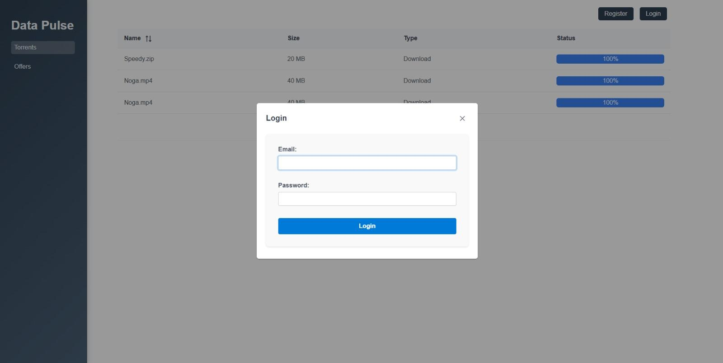


6.2 First-Time User Registration
- Click the ‘Register’ button on the login screen
- Provide a valid email address
- Create a secure password
- The system checks the email format and verifies that it is not already
registered.
- After successful registration, you must complete the Login process to access
the system.
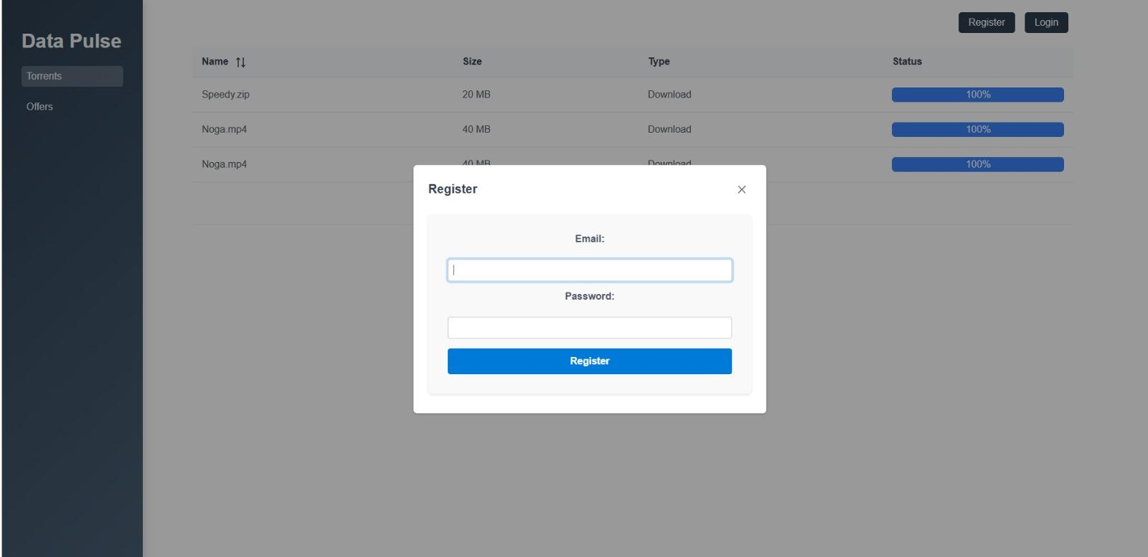

Main Interface

6.3 Navigation System
The interface is organized with:
- Left sidebar for main navigation, providing quick access to essential features with two sections:
- Torrents: Displays available files for download.
- Offers: Allows users to suggest and request new files.
- Category bar for easy browsing, listing file categories such as Games, Programs, Movies, and More, helping users find relevant content efficiently.

6.4 File Management

6.4.1 Uploading Files

- Locate the file you want to share on your computer
- Click the ‘Upload File’ button
- In the pop-up window, paste or type the full file path
- Click ‘Upload’ to initiate the process
System automatically:
The system automatically checks if the file already exists in the system. If not, it prepares the file for future downloads by other users by splitting it into chunks, compressing each chunk into a ZIP file, and saving the chunks in the ‘Chunks’ directory.

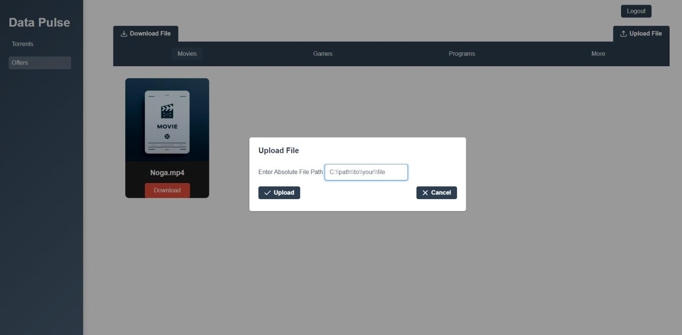

💡 Upload Tips:
- Keep your file paths organized for easy access
- Ensure you have sufficient storage space

6.4.2 Downloading Files
Two Download Methods:
- Direct UI Download
- Browse files in the system
- Click the "Download" button next to desired file

- System begins download process automatically


- Torrent File Download
- Click "Download File" button
- File explorer opens
- Navigate through your computer's directories
- Select a torrent file
- System initiates download based on torrent file
- Track download progress in Torrents section (left sidebar)
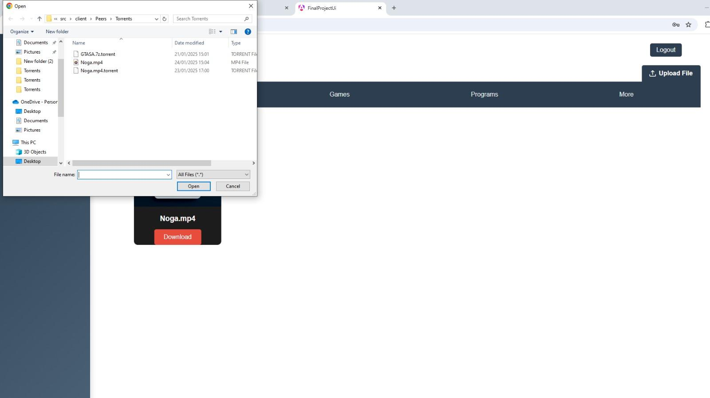
System automatically:
The system downloads the file in chunks and stores them in the Chunks’ directory for future sharing. It then assembles the complete file in the ‘Files’ directory and makes it available for other users' download requests.
💡 Download Tips:
- Use direct UI download for files already in the system
- Use torrent file download when you have a specific torrent file
- Monitor progress through the Torrents section
- Check FILES directory for completed downloads
- Chunks are automatically saved for sharing with other users

6.5 File Organization
Browse through categories under Torrents:
- Movies: Video content and films
- Games: Gaming software and related files
- Programs: Applications and software
- More: Additional file categories

6.6 Real-Time Monitoring
Track your files with detailed information:
- File name: Complete title of the file
- File size: Size in appropriate units (MB/GB)
- File type: Format and extension
- Status: Live progress percentage during transfer
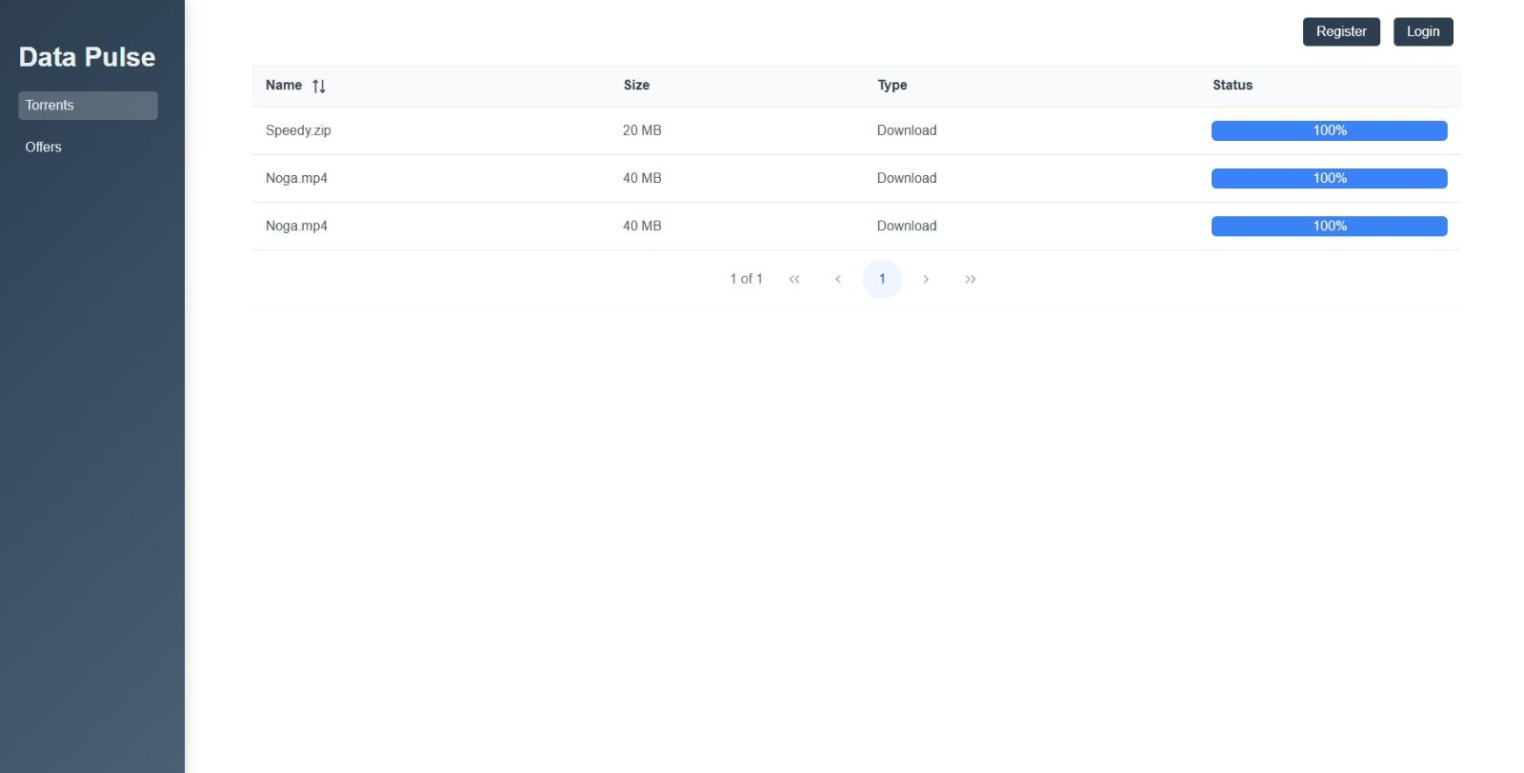
Quick Reference:
- Files are automatically split into chunks for efficient sharing
- Downloaded files are stored in the ‘Files’ directory
- Uploaded chunks are stored in the ‘Chunks’ directory
- Monitor download progress in the Torrents section

Maintenance Guide
Purpose
To enable continued use, maintenance, and improvement of the project after completion. This includes implementing changes, updates, and improvements to extend the system's lifecycle and usability.

7.1 System Overview

DataPulse enables users to efficiently share and download files using a hybrid peer-to-peer (P2P) and tracker-based architecture. With end-to-end encryption (RSA & AES), multi-threaded downloads, and a real-time tracker, DataPulse ensures a fast, secure, and scalable file-sharing experience.

7.1.1 Main Components
- Frontend (Angular) - User Interface
- Client Backend (Flask) - Client Server
- Tracker (FastAPI) - Central Server

7.2 Features
- P2P File Sharing – Efficient and decentralized file transfer.
- Multi-Threaded Parallel Downloads – Download files from multiple peers simultaneously for speed.
- End-to-End Encryption – RSA and AES encryption for secure data transfer.
- FastAPI Tracker – Manages peers and files with high efficiency.
- Flask Backend – Handles user authentication, file uploads, and downloads.
- MongoDB Database – Stores peer and file metadata.
- Real-Time Peer Updates – Prevents busy peers from being selected for downloads.
- Netflix-Like Offers Component – Users can browse and download files categorized as Movies, Games, Programs, and more through an intuitive interface.

7.3 How DataPulse Works
- User Login & Authentication – Users log in via the UI, and authentication is handled via the Tracker.
- File Discovery & Peer Selection – The Tracker returns a list of peers that have the required file chunks.
- Secure Key Exchange (RSA) – Before downloading, the client requests the peer's public key.
- Chunked Parallel Download (Multi-Threading) – Simultaneous downloads from multiple peers.
- File Merging & Verification – Ensures integrity using SHA-1 hash checks.
- Upload Handling – Peers also serve files to others, updating their availability in real-time.

7.4 System Requirements

7.4.1 Software Requirements
- Python 3.8 or higher
- Node.js & npm (for Frontend)
- MongoDB

7.5 Installation Process
Tracker Installation (FastAPI)
- Switch to tracker branch: git checkout tracker
- Install dependencies: pip install -r requirements.txt
- Start the server: uvicorn app.main:app --host 0.0.0.0 --port 8000 --reload
Client Backend Installation (Flask)
- Switch to client-backend branch: git checkout client-backend
- Install dependencies: pip install -r requirements.txt
- Run the backend that communicates with both the UI and the Tracker: python main.py
Frontend Installation (Angular)
- Switch to main branch: git checkout main
- Install dependencies: npm instal
- Start the application: npm start
- This starts the Angular UI at http://localhost:4200

7.6 Security Configuration

7.6.1 Encryption Settings
- RSA key size: 2048 bits (configurable in key_exchange.py)
- AES key size: 256 bits (configurable in encryption_utils.py)
- End-to-end encryption between peers

7.6.2 Authentication
- JWT-based authentication
- Token-based peer verification
- Secure password storage in MongoDB

7.7 Troubleshooting Guide
Connection Issues
Tracker Connection Failed:
- Verify tracker is running on port 8000
- Check network firewall settings
- Verify MongoDB connection
Peer Connection Issues:
- Check if peer is marked as busy
- Verify port accessibility
- Check encryption key exchange
File Transfer Problems:
- Verify available disk space
- Check chunk integrity
- Monitor download progress

7.8 Monitoring and Recovery
Key Metrics
System Performance:
- Active connections
- Download speeds
- Chunk transfer success rate
- Peer availability

Security Monitoring:
- Failed login attempts
- Encryption failures
- Invalid peer requests

Recovery Procedures
- Stop all services
- Restore from backup
- Verify system integrity
- Restart services

7.9 Update Process
- Notify users of maintenance window
- Stop services in order:
  - Frontend
  - Client Backend
  - Tracker
- Backup current state
- Pull latest code
- Update dependencies
- Run tests
- Restart services
- Verify functionality

7.10 Future Improvements
- Enhanced File Integrity Verification
To further improve file integrity in DataPulse, a Cyclic Redundancy Check (CRC) mechanism could be integrated alongside the existing SHA-1 hash verification. While SHA-1 ensures overall file validation, CRC would provide an additional layer of protection by detecting corruption in individual chunks during transfer. Implementing this real-time verification mechanism would allow the system to identify and retry corrupted chunks automatically, ensuring that only valid data is assembled into the final file.
Proposed Development Steps
- Develop and integrate a CRC calculation module.
- Modify the chunk transfer protocol to include CRC verification.
- Update the file validation process to incorporate CRC alongside SHA-1.
- Conduct thorough testing to validate the integrity checks.

- Desktop Application Development
Transitioning DataPulse from a web-based platform to a dedicated desktop application could provide several benefits, including better system integration, improved file management, and a more seamless user experience. A desktop version would eliminate the need for manual path entry, allowing users to navigate their file system more naturally. Additionally, it could offer features such as drag-and-drop file uploads, system tray integration, automatic updates, and local file indexing, making file sharing more efficient and user-friendly.
Proposed Development Steps
- Select a cross-platform framework (such as Electron) for compatibility across Windows, macOS, and Linux.
- Implement file system integration to allow native file browsing.
- Develop UI components optimized for desktop use.
- Create an automatic update system to ensure users always have the latest version.
- Migrate existing web-based features to the desktop environment.
- Conduct thorough testing across multiple platforms.

7.10 System Architecture and Process Flows
The following sections present visual representations of the system's architecture and key processes, specifically the file upload and download workflows. These diagrams demonstrate the interaction between system components and the sequence of operations that occur during file transfers, helping developers and system administrators understand the system's behavior at a granular level.
The process flows detailed below illustrate two fundamental operations in DataPulse:
- File Download Process: Demonstrates how files are requested, retrieved from peers, and verified
- File Upload Process: Shows how files are processed, encrypted, and made available to other users

File Download Process Flow
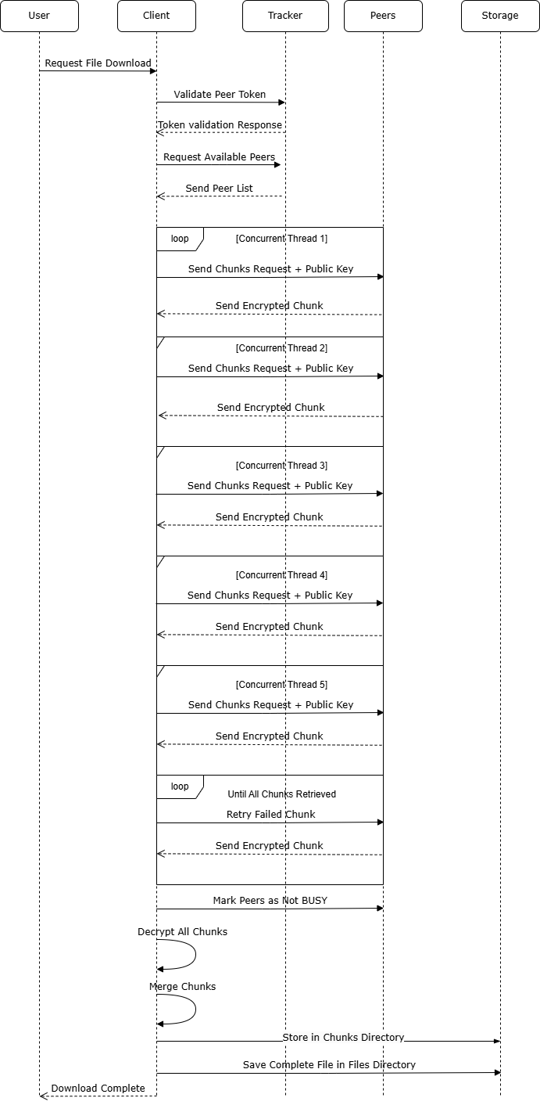

File Upload Process Flow
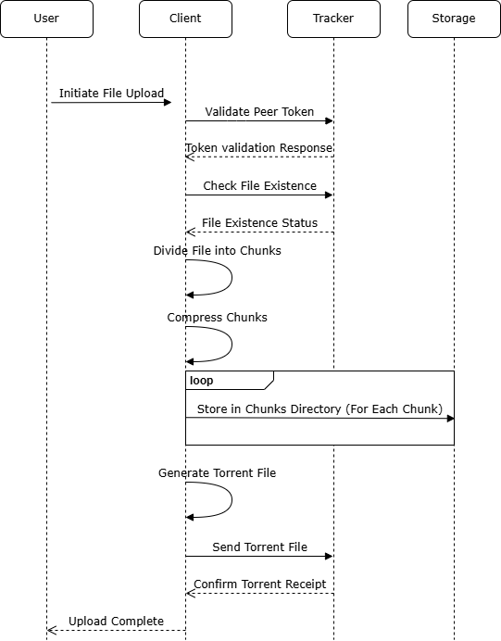
Each flow diagram represents the complete sequence of operations and interactions between system components, helping to visualize the complex processes that enable secure P2P file sharing in DataPulse.

References
- Bharambe, A. R., Agrawal, C., & Seshan, S. (2006). Analyzing and improving BitTorrent performance. ResearchGate. Retrieved from https://www.researchgate.net/profile/Ashwin-Bharambe/publication/245396846_Analyzing_and_Improving_BitTorrent_Performance/links/54ef331d0cf2495330e1b8ac/Analyzing-and-Improving-BitTorrent-Performance.pdf
- Qiu, D., & Srikant, R. (2010). Modeling and performance analysis of BitTorrent-like peer-to-peer networks. Peer-to-Peer Networking and Applications, 1(2), 85-91. https://doi.org/10.1007/s12083-010-0070-6
- Knežević, P. (2005). Design and analysis of a peer-to-peer distributed system for dynamic networks (Doctoral dissertation). Technical University of Darmstadt. Retrieved from https://tuprints.ulb.tu-darmstadt.de/854/1/knezevic_thesis.pdf
- Qiu, D., & Srikant, R. (2004). Modeling and performance analysis of BitTorrent-like peer-to-peer networks. Proceedings IEEE INFOCOM 2004, 1, 367-377. https://doi.org/10.1109/INFCOM.2004.1354521
- Legout, A., & Nardelli, L. (2002). Rarest first and choke algorithms are enough. INRIA Research Report RR-4725. Retrieved from https://inria.hal.science/inria-00000156
- Federal Information Processing Standards (FIPS). (2001). Advanced encryption standard (AES). National Institute of Standards and Technology. Retrieved from https://nvlpubs.nist.gov/nistpubs/FIPS/NIST.FIPS.197.pdf
- Osvik, D. A., Shamir, A., & Tromer, E. (2005). Cache attacks and countermeasures: The case of AES. eprint.iacr.org. https://eprint.iacr.org/2005/067.pdf
- Kapoor, A. (2022). AES, DES, and RSA: A comprehensive study on data security mechanisms. SSRN. Retrieved from https://papers.ssrn.com/sol3/papers.cfm?abstract_id=4267943
- Nikam, P. R., Parvat, B. R., & Kamat, R. K. (2015). A survey on man-in-the-middle attack. IEEE Xplore. Retrieved from https://ieeexplore.ieee.org/document/7442758
- Legout, A., & Nardelli, L. (2002). Rarest First and Choke Algorithms Are Enough. INRIA Research Report RR-4725. Retrieved from https://inria.hal.science/inria-00000156

